**Status Report Regarding the High Voltage Transformer:**

Currently, Khalid has chosen to move forward with some neon transformers rated at 3kV found [here](https://www.amazon.com/dp/B06XWC7JFX/ref=sspa_dk_detail_9?psc=1&pd_rd_i=B06XWC7JFX&pd_rd_wg=TF7Dl&pd_rd_r=GMA59184ZBSPM3H0PCH4&pd_rd_w=EiqhG).

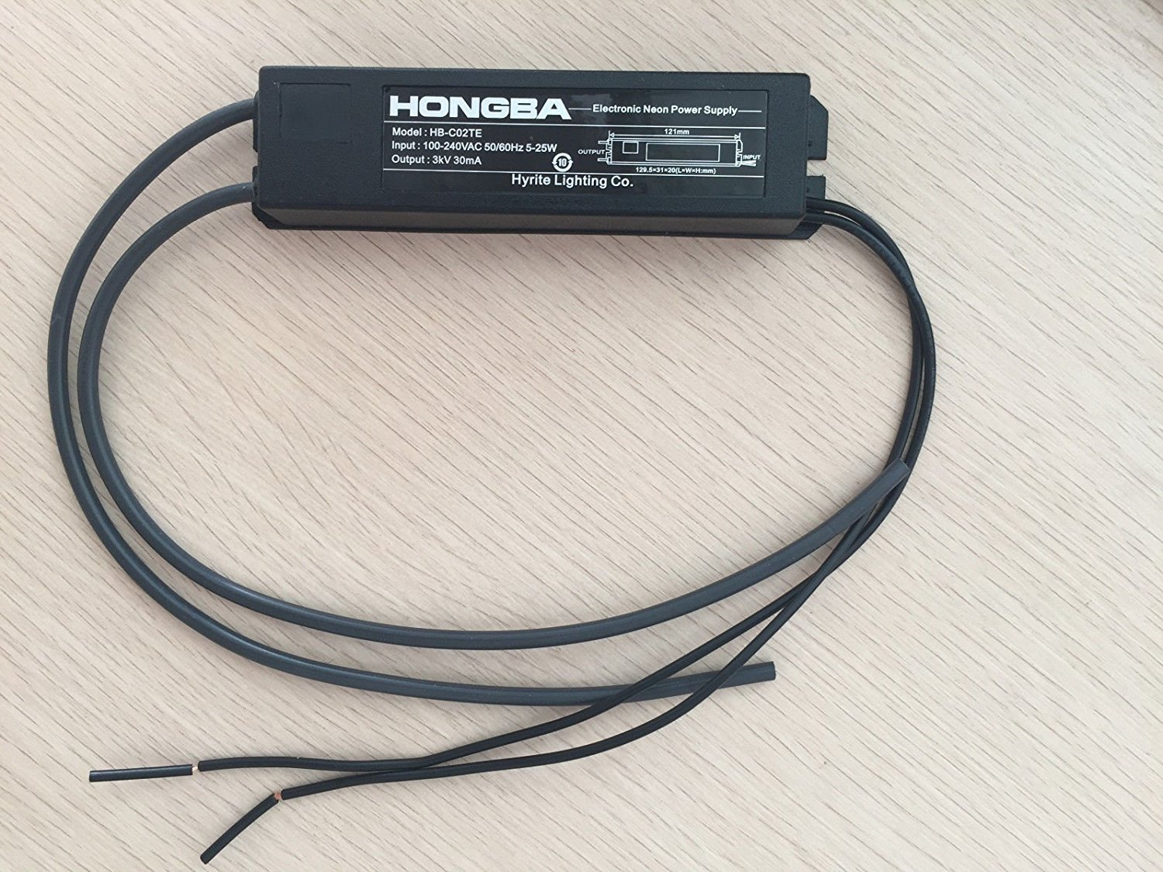However, there are some complications. One of these transformers will only output 30mA according to the advertisement. Currently, no datasheet has been found for this transformer, so it is hard to find the VA of the component. Connecting four of these transformers in parallel will provide the necessary amperage needed to power the plasma reactor, so four of these neon transformers will be needed. For safety reasons, this exact model of transformer may not be chosen as it is proving difficult to find a datasheet. However, we have found online resources offering several different types of neon transformers with their respective datasheets.

In summary, Khalid has chosen to continue with these transformers until another one with a datasheet is found. Unfortunately, there is also the risk of ripple current. Because of such high voltage, there will be a very large ripple current. This requires a capacitor to filter this out. However, the equivalent series resistance would be lessened as we add more capacitance in parallel so several capacitors shall be used. With enough capacitance, we should be able to minimize much of the ripple current enough to where it will not damage the plasma reactor.

The capacitor voltages must be rated at least 4.6kV. This is because the voltage on them should never spike above 2/3 of their rating. Therefore, we need to find a datasheet, because the percent error is not known. If we knew the percent error, we would be able to know how much the capacitors need to be above the maximum amount of voltage they would be subjected to. This also applies to the rectifier bridge.

In the diagram below, you will see the four transformers connected in parallel. These are all connected to the wall socket on the in-side, and the out is connected in parallel to a rectifier bridge. This rectifier must have a reverse tolerance of at least 6kV + 2 * (%error of transformer voltage). You will also notice the capacitors in parallel to lessen the ripple current. This is all connected to the plasma reactor.

